**Working with Git Repository**

**Step 1:**

Go to github.com and click the 'New repository' option under the '+' icon.

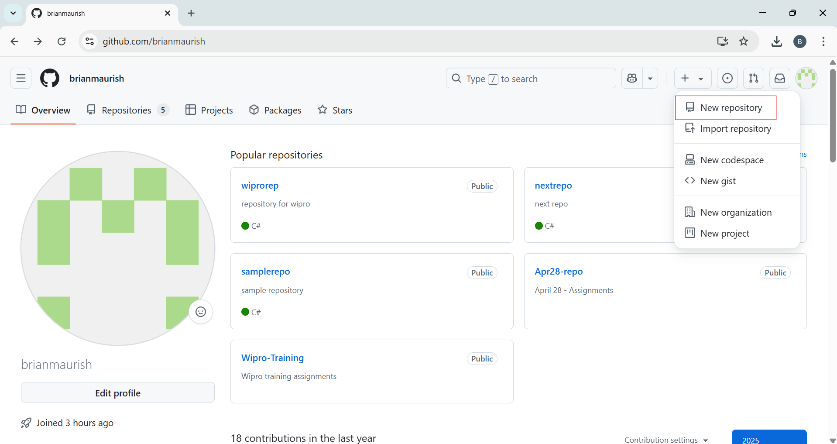

**Step 2:**

Enter the repository name and description, then click the 'Create repository' button.

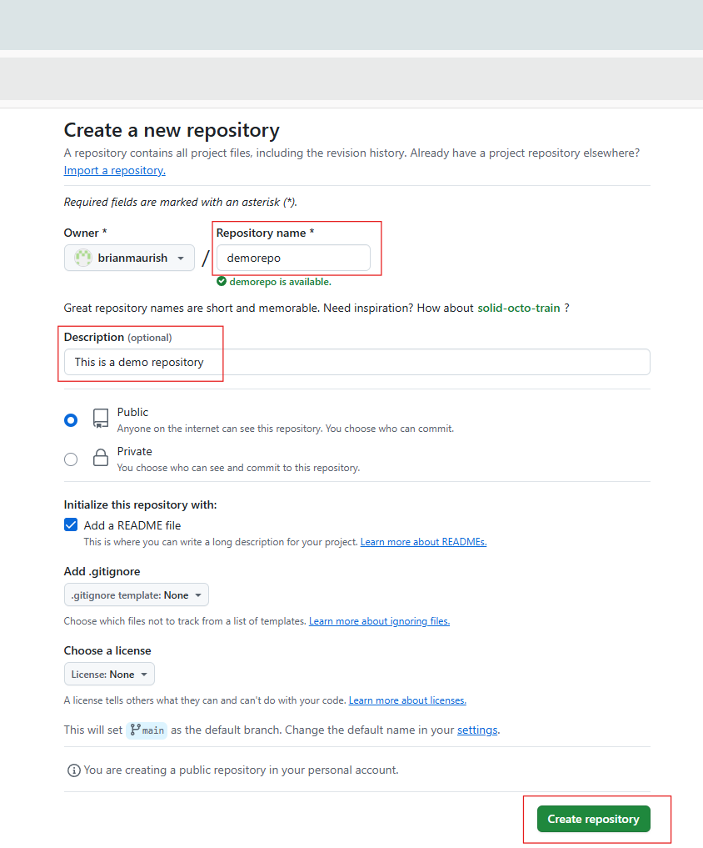

**Step 3:**

A new repository is created, then click on the 'Code' button and copy the URL.

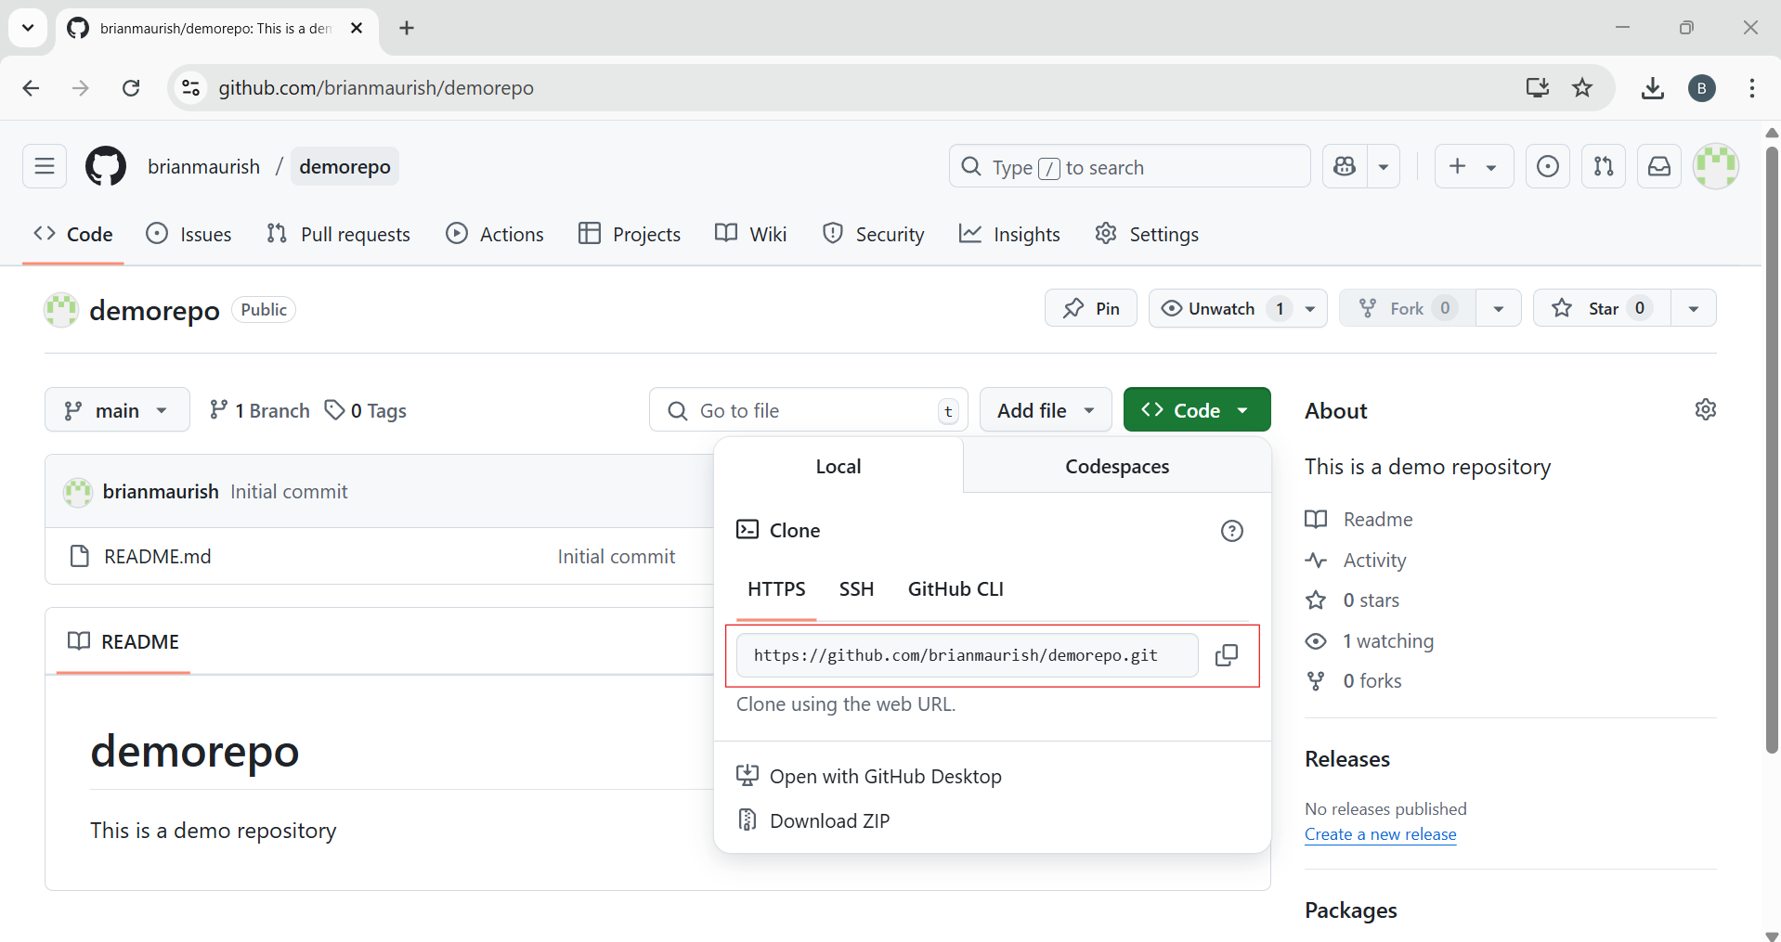

**Step 4:**

Open VS Code, and in the terminal, type git clone, paste the link copied from the Git repository, then press Enter.

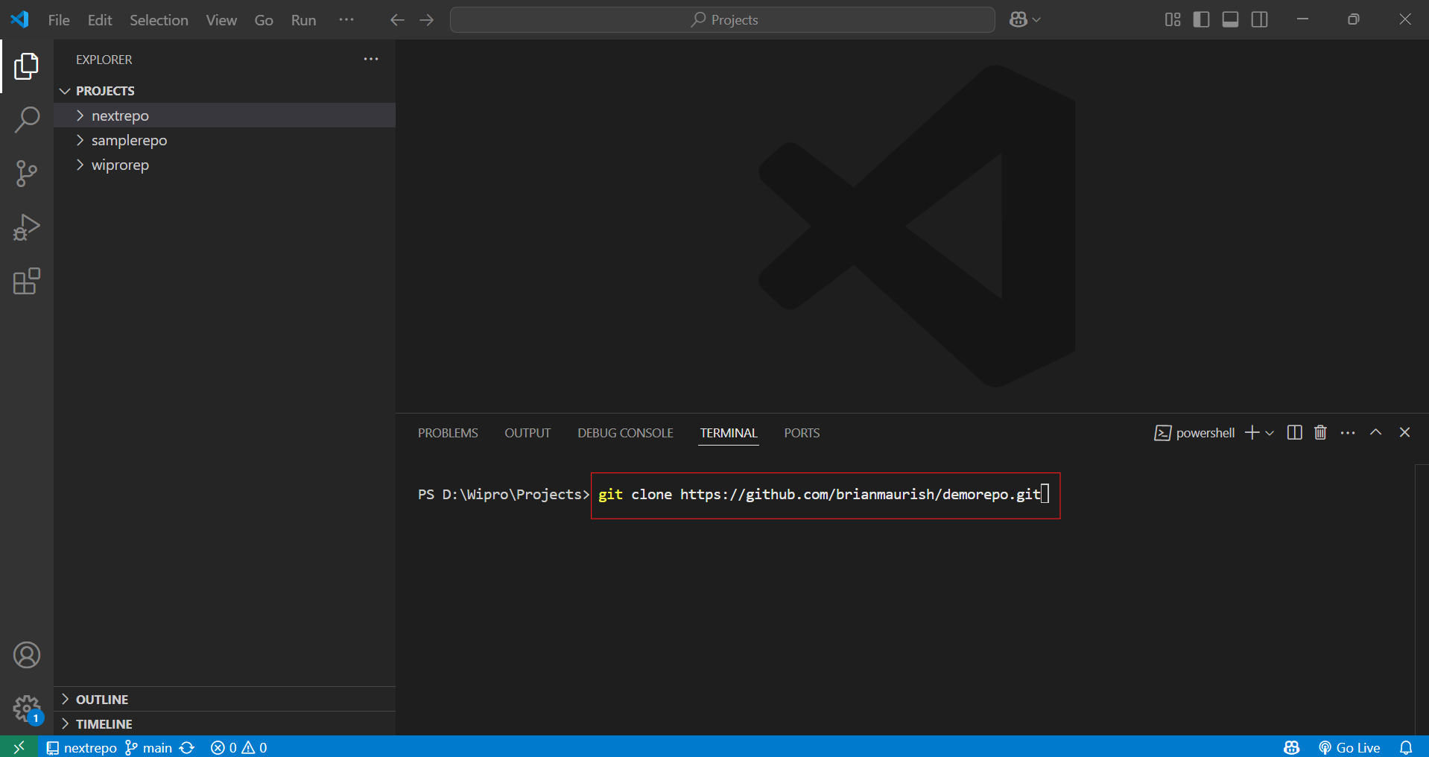

**Step 5:**

Create a .cs file inside the demorepo folder and write the code in it.

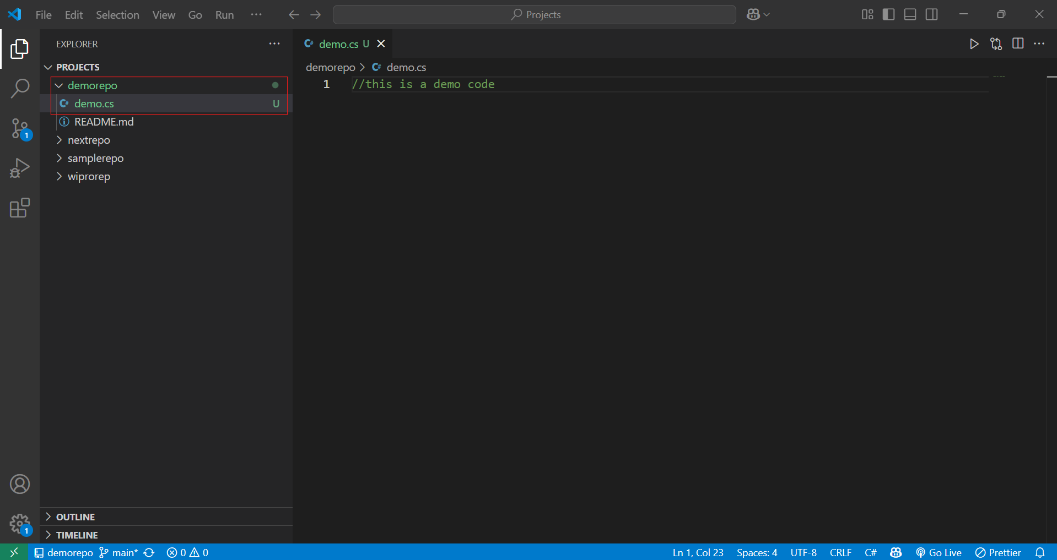

**Step 6:**

Click the Source Control icon, type a commit message under ‘demorepo’, and select the ‘Commit & Push’ option.

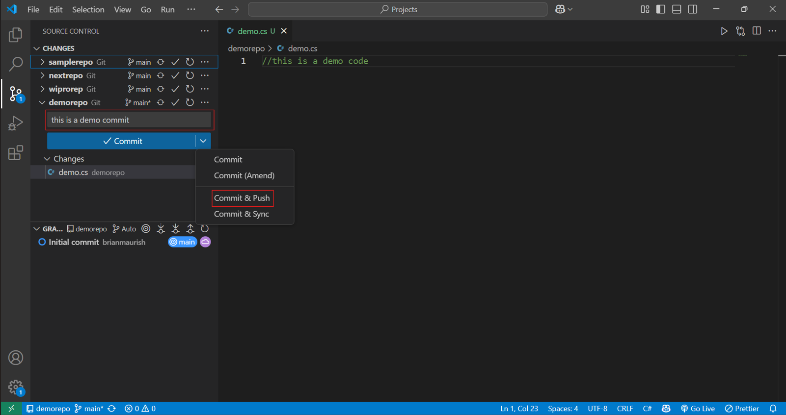

**Step 7:**

The code will be committed to the Git repository. You can refresh the GitHub page to see the demo.cs file.

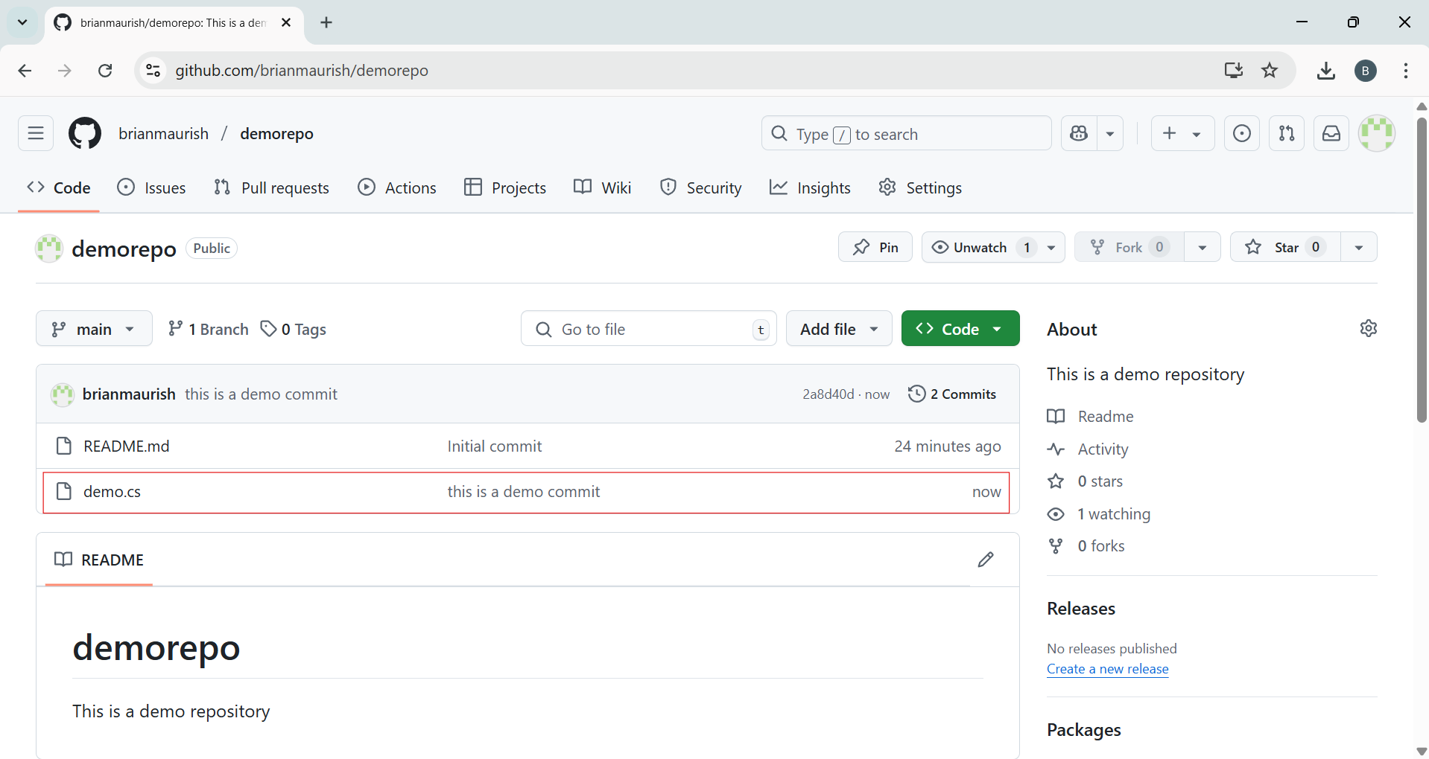

**Step 8:**

We can open the demo.cs file on GitHub to view the committed code.

